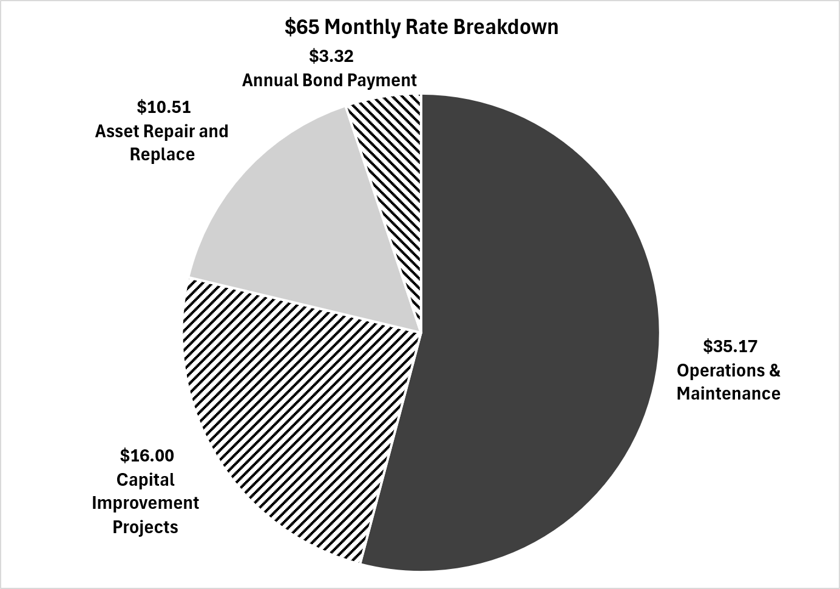
Notice of Monthly Service Fee Increase

Dear Eagle Sewer District Parton,
We are committed to providing dependable wastewater service while protecting public health and the environment. To continue maintaining our system and preparing for the needs of our growing community, our monthly service fee will be increasing.

Effective December 1, 2026, Eagle Sewer District’s monthly service fee has been increased from $45 per month to $65 per month.
Commercial customers and multiple residential units will see their monthly bill increase accordingly.
The Eagle Sewer District’s Board of Directors implemented the fee increase at the Public Hearing held on August 10, 2026.
Why is this adjustment needed?
- Maintain and improve the wastewater collection and treatment system that serves our community.
- Address increasing wastewater treatment costs charged by our partner, the City of Boise.
- Invest in infrastructure needed to support future Class A irrigation reuse water.
We recognize that changes to monthly bills affect household and business budgets. Thank you for understanding as we make the investments necessary to provide safe, reliable service now and into the future.

